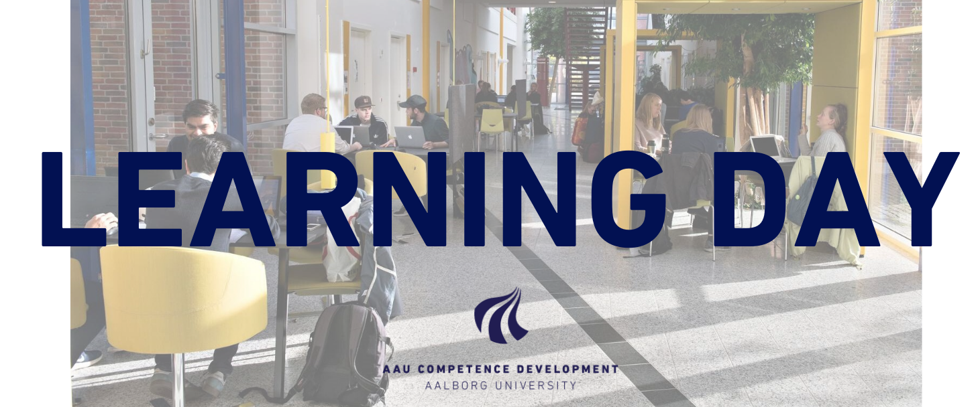
The AAU Learning Day 2020 takes place on 5 May in Copenhagen and 6 May in Aalborg.

CALL FOR WORKSHOPS AND POSTERS
The overall themes for the AAU Learning Day 2020 are Diversity and Interaction. Based on the evaluations from previous events, we want to ensure that the conference activities match the themes. Dialogue and sharing experiences across AAU will therefore be highly prioritised for this event.
We hereby invite all faculty staff to actively participate in the conference by sharing their teaching experiences and ideas related to the themes Diversity and Interaction in workshops and on posters.
Suggested topics (can include but not limited to):
- Digital vs. Analogue teaching: tools, possibilities and limitations
- Mega-projects and interdisciplinarity: experiences, perspectives and setting-up
- PBL – diversity as a strength rather than an object of conflict
- The influence of physical space on learning
- Feedback and discussion with colleagues
- Well-being (e.g. conflict resolution in study groups or management of students with physical or mental challenges)
- Project supervision
- Sustainable Development Goals in education
- Design Thinking as a method for pedagogical innovation
- Progression in project work

Deadline: Please submit your workshop or poster proposal no later than 3 February 2020.
The organising group will revise all submitted workshop and poster proposals and will inform all presenters whether their abstracts have been accepted in the beginning of March 2020.

WORKSHOPS
The duration of a workshop will be 1½ hours. The content of the workshop must focus on learning practises, exchange of experiences and co-creation, moreover discussions and active participation are expected.
If you prefer a shorter workshop, you can choose a timeslot of 45 minutes (½ workshop session) and share the workshop session with a colleague. In the abstract template, you can indicate if you have already found a colleague for the other half of the workshop session or if you prefer that the organising group finds a suitable collaborator for your workshop.
The maximum number of participants for each workshop will be 25 but will depend on the number of registrations.
Send a short abstract including title, theme and points/questions for discussion. Please use the template below.

POSTERS
The conference will have an open poster session in connection with the lunch break. The session will not include formal poster presentations but the poster author(s) will stand by the posters, ready to engage in dialogue with the conference participants.
The poster must focus on learning practises, sharing experiences on specific learning design and similar. Preferably, the poster should include talking points for open discussion.
Send a short abstract including title, theme and points/questions for debate. Please use the template below.
AAU Competence Development will assist with getting the posters printed.

ABSTRACT TEMPLATE FOR THE AAU LEARNING DAY 2020
Please fill in this form and send it to tco@adm.aau.dk
Deadline is 3 February 2020
The organising group will then revise all submitted workshop and poster proposals and will inform all presenters whether their abstracts have been accepted in the beginning of March 2020.

Name
Name(s) of poster owner(s) or workshop presenter(s):____________
Department(s):___________

Presentation format
Tick the box indicating the type of presentation:
Poster
Entire workshop session (1½ hours)
A half workshop session (45 min.)

If you only wish to register half a workshop session, please answer the following question:
I have already found a colleague for the other half of the workshop session (yes/no):________
If yes, please write the name of the colleague(s) responsible for the other half of the workshop session:______________
If no, the organising group will try to find a suitable match for your workshop.

Title and content
Title of the poster or workshop:_________________
Programme text (max 200 characters):_____________
Abstract including points for debate and a short description of how active participation is expected to be a part of the presentation (max 2000 characters):__________________

Special requirements
Do you have special requirements regarding your poster/workshop (i.g. printed materials or projector), you can write them here:_________

Venue
Please indicate where you want to participate with your poster/workshop:
Copenhagen, 5 May 2020
Aalborg, 6 May 2020
Both days

